REQUEST FOR PROPOSAL (RFP)
INVITATION OF TENDERS FOR
CONSTRUCTION OF NEW GYM HALL AT RSAOI BANGALORE

1. Eligible bidders are invited to participate in the Two Bid System based process for selection of agency/ vendor to execute the project whose details are captioned above and a sketch is att as annexure VI. Sealed quotations may be dropped in the designated Quotation box, Pre Bid Meeting(s) shall be held at RSAOI to help bidder understand the granular details of the project.

2. Bids shall be submitted in two separate envelopes, under two bid system (Technical & Commercial bid).

3. Envelops must be enfaced “RFP- 01 of Sep 2026 - CONSTRUCTION OF GYM HALL AT RSAOI BANGALORE” – Email and Phone No of the bidder shall be endorsed on the packet compulsorily with clear written – Tech Bid / Fin Bid – (as applicable). Commercial Bids shall compulsorily accompany with a ‘Self Addressed Envelop’ for return of unopened bids.

Dates

4.1 Date of issue of RFP. The RFP shall be loaded on to the website of RSAOI and a link shall be given in newspaper advertisement which shall be published for wider publicity. The newspaper publication shall be designated as the dt of publication.

4.2 Date of Pre Bid Meeting. at RSAOI on the 07th day of publication i.e. 01 Oct 2026. There may arise a case that the Pre-Bid Meeting(s) may have to be conducted on subsequent days, in such a case it shall be conducted on 03 & 04 Oct 2026. The minutes of Pre-Bid Meeting shall be recorded by the Secy, RSAOI. Details of all vendors/ agencies/ bidders shall be collected and they shall be informed by Telephone Message and by Email the relevant details as validated by the management. These details must be adhered to while submitting Tech bid.

4.3 Last date for submission of Tech Bids and Fin Offer. To be declared during the Pre Bid meeting, followed by email and telephone message with min of clear seven (07 days) preparation time with the bidders. Mode of submission of bids shall be physical envelops and any bids over eMail shall not be presented to the BOO.

4.4 Tech Bid Envelops Opening and Evaluation – Tech Bids shall be evaluated by BOO.

4.5 Return of Fin Offers where Tech Bids Do Not Qualify. - BOO shall hand over the Fin Bid Envelops for returning to bidders without opening the sealed envelopes. All fin bids shall be accompanied by a return envelope with postage duly paid and in case not accompanied by the same, is liable to be disqualified on Tech Grounds.

5. All conditions and parameters will be evaluated with reference to firms submitting tenders. RSAOI BANGALORE reserves the right to reject any/all applications without assigning any reason whatsover.

6. The Scope of Work/ Specifications of the “CONSTRUCTION OF GYM HALL AT RSAOI BANGALORE” are attached at Annexure I. However, it shall be amplified and subject to amendments during the Pre-Bid Meeting.

Terms and Conditions

7. The “CONSTRUCTION OF GYM HALL AT RSAOI BANGALORE” is required to be completed within a period of 100 days commencing from the date of acceptance of the offer. Any delay in execution of work from the stipulated period will attract penalty of 0.5% per week of delay (06 working days) or in proportion there of the Bid amount. RSAOI, Bangalore reserves its right to recover the amount either in kind or cash as the case may be for such penalty.

8. Sample Clause. Items for which samples are mandatorily required at the Tech Evaluation Stage shall be announced and emailed post Pre-Bid Meeting. Samples which do not meet approval of the management shall entail the Mother Tech Bid rejection. Samples of the item for constrs can also be asked to be deposited by the successful bidder which shall thereafter be used by the PMG to validated the actual quality of constr. Samples shall be inspected by Nominee/ Secy/ BOO/ PMG on behalf of the management. Samples, if not deposited by each bidder where due, as announced in the Pre-Bid Meeting, whether brocheure, authority letter/ part or equipment, wherever called for and discussed during the Pre-Bid Meeting, shall be deposited to RSAOI as part of Tech Bids, individual bidders shall be responsible for carriage to and fro and shall be on ‘No Cost, No Commitment’ to the RSAOI. Samples of firms which fail to quality shall be returnable within 30 days. Samples must contain mob nos for conveying a message.

9. The area shall be covered with metal canvas sheets during the work is in progress, any vehicle leaving the area must not leave a trail of dirt in the premises, the mgt shall levy charges as per its own volition in such a case.

10. Previous Invoices and their Contact Nos. Previous invoices of customers where such projects have been executed earlier shall be shared in the Tech Bid. Photographs of previous wok executed, tech parameters of equipment and bill of fare (rates of each equipment sold at the rates along with location of installation and Contact Nos) shall be shared in the Tech Bid.

Risk and Expenses

11. Unfinished or work not undertaken to the desired quality can be undertaken under the Risk and Expense of the vendor. While undertaking this, the labor rates shall be as extant hirings of the RSAOI and rates of equipment can vary ~15%. Whenever the risk and expense is being carried out, the amount due to the vendor can be paid anytime upto 12 month extendable upto 18 month beyond which the RSAOI shall pay a nominal interest of 2.5% PA.

12. Permission from Agencies. Permission from agencies, whatever and whenever required, incl BMRCL or MES shall be the duty of bidder. All arrangements incl permissions from any agency incl civil or military for the project work shall be the responsibility of selected Bidder only. Men/ material support will not be offered by RSAOI, Bangalore.

Mandatory Documents

13. The following mandatory documents will be attached in Tech bid. Non – Submission shall be liable to bid rejection:-

13.1 Common Documents

13.2 Copy of License/registration in the name of the Firm. The Bidder should be either a registered company or registered partnership or sole proprietorship firm (proof to be attached).

13.3 Proof of own infrastructure and office with documents (Brochures, leaflets, manuals etc, if any).

13.4 Copy of PAN card and Income Tax return for last three years.

13.5 Details of GST number be reflected in the quotation.

13.6 Certificate as per format attached at Annexure – II to this RFP on Company/Firm Letter Head.

13.7 CIBIL score of the Director/owner of firm.

Documents For Specific Project

14. Technical specifications of the materials /equipment / components. Please note that RSAOI, Bangalore reserves the right to reject your bid in case you do not specify the brands you shall utilize of various material and fail to include the issues discussed in the Pre-Bid Meeting.

14.1 Bidder/Organization profile as per Annexure III.

14.2 The Bidder may be required to produce all original documents for verification by the Board of Officers or authorized staff of RSAOI, Bangalore Management Committee on demand for checking the credentials of the Bidder.

Payment Bank Guarantee (PBG) and Earnest Money Deposit (EMD)

15.1 Successful bidder shall only resume work once Samples and a Payment Bank Guarantee of Rs 5 Lacs (Five Lacs Only) valid for 3 years is deposited by the bidder.

15.2 Bidders are required to submit Earnest Money Deposit (EMD) for an amount of Rs 1,00,000/- (Rupees One Lakh only) along with their Quotation, in favor of RSAOI, Bangalore.

15.3 The EMD may be submitted in the form of Demand Draft/Fixed Deposit Receipt/Bank Guarantee from any of the public sector banks or a private sector bank authorized to conduct government business with validity as good as the bid validity.

15.4 EMD of the unsuccessful bidders will be returned on award of the project work.

15.5 The EMD of the successful bidder would be retained until Performance Bank Guarantee (PBG) is recd.

15.6 PBG and EMD shall receive no interest whatsoever.

15.7 RSAOI, Bangalore reserves the right to encash the PBG based on BOO from situations emanating from abandonment, Cancellation of Contract, or as Penalty for delayed work. In case the building fails to function as intended, the PBG can be presented to the bank for monetization without notice, however, it shall be based on a BOO.

Arbitration

16. In case of any dispute, including monetization of PBG the arbitrator shall be nominated by RSAOI who may be a member of the club. The decision of the arbitrator shall be on the both parties. Arbitrator shall receive Rs 2000/- per day to be payable by the firm.

17. Only Physical Bids dropped in the Tender Box placed at RSAOI BANGALORE” Gate No 2, C/o HQ K & K Sub Area or by post to RSAOI, MG Road, Bangalore – 560001 shall be eligible for consideration. Any bid received after the deadline for submission of bid prescribed, will NOT be entertained and returned unopened to the Bidder.

18. Fin Bid Format. The fin bid format is given at Annexure IV. Erasers, alterations, incomplete details, blank in part of full shall be rejected.

19. Validity of Offer. The offer of quotation should be valid for period of minimum 180 days from the date of opening of quotations. The EMD must be equally valid.

20. Application of Quality Based Framework. RSAOI Mgt is under no obligation to accept the lowest or any other offer received in response to this notice. There exists no commitment to accept lower/ lowest or any tender and a Quality Based Framework can be drawn by RSAOI to technically validate bidders by a BOO. The mgt may select vendor based on quality based frame work (QBF) driven by an internal committee. RSAOI Mgt shall not under any obligation to select or apportion. RSAOI shall be entitled to reject any or all offers without assigning any reasons whatsoever.

21. Opening of Quotations. Quotations will be opened by Bd of offrs.

22. Order Cancellation. If the selected Bidder fails to carry out/ start the assigned job within the stipulated time schedule or the extended date communicated, RSAOI BANGALORE reserves the right to cancel the order.

Payment Terms.

23. No advance amount shall be paid.

24. GST shall be paid only on production of auditable payment trail with HSN Numbers.

25. The final payment shall be made only upon completion of the assigned job/completion of the work as per Scope of work and authenticated by Board of Officers.

26. Proper Invoice, with GST payment details, will be submitted by the Bidder to RSAOI BANGALORE, on completion of work and other formalities.

27. On scrutiny of the invoice/ bill, RSAOI BANGALORE on recommendations of the Board of Offrs convened by HQ KKSA, shall make payment after deduction of payable TDS as applicable.

28. Applicability of Force Majeure Conditions. The Force Majeure conditions will be applied to the both parties till completion of the project work “CONSTRUCTION OF GYM HALL AT RSAOI BANGALORE” as per the law of the land.

29. Termination of Contract. RSAOI BANGALORE reserves the right to terminate the contract in the event of non-performance / non-adherence to laid down quality and Current Good Engineering Practices / illegal / unethical practices.

30. Clarification Regarding Contents of RFP. Can be clarified during Pre-Bid Meeting only.

31. Any unforeseen situations such as Resultant Single Vendor Situation (RSVS), difference in Tech Parameters, opinions and Force Majeure shall be dealt through a BOO at the behest of the management, whose decision shall be final and binding on all parties.

32. RFP part of Bid Document. Not contained anywhere else or whatever the status, RFP itself shall form part of the bid document and each bidder shall be required to sign on each page as acceptance of terms and conditions in the RFP.

Rules Governing Pre Bid Meeting

33.1 Attendance. Bidders can participate by themselves or through their representatives in the Pre Bid Meeting.

33.2 Clarifications, as given in the Pre Bid Meeting shall be emailed to only those who endorse their email in the Attendance Sheet.

33.3 Absentees can place bids, however, all clarifications and decisions shall be applicable to all bidders in a manner that they were present during the Pre-Bid Meeting.

33.4 The minutes of the Pre-Bid Meeting shall be displayed on the RSAOI Website.

34. For the purpose of entry to premises for drop of bids and for Pre Bid Meeting, the RFP itself shall be construed as a pass valid for one(01) person, however, the visitors shall only visit specific areas and cannot envisage themselves to be at par with members.

35. Bidders are advised to ensure they receive updates from following connecting credentials on their email and phone. Contact address/tele Nos are as under:-

The Secretary,

RSAOI Bangalore
HQ K&K Sub Area
Bangalore – 560001
Email: info@rsaoibangalore.in
Tele : 9486524069

Note :- Please Download Excel File : Gym Scope wk

Annexure – II
(Part of tech bid)

(LETTER OF THE BIDDER ON LETTERHEAD)

The Secretary,
RSAOI BANGALORE
HQ K&K Sub Area
Bangalore – 560001
Email: info@rsaoibangalore.in
Tele : 9486524069

Tech Bid
CONSTRUCTION OF NEW GYM HALL AT RSAOI

Dear Sir,

1. With reference to your RFP RFP- 01 of Sept 2026 dated _________ 2026 followed by the Pre-Bid Meeting, subject work and having examined and understood the instructions, terms and conditions forming part of the RFP and Pre Bid Meeting, we hereby declare that we understand that all Terms and Conditions given in the RFP (Pl sign on each page of RFP and att)

2. The Pre-Bid Meeting was attended by our rep namely………………………………..Mob No………………………………………… OR our rep could not attend but all conditions are acceptable to us.

2. Pl find enclose our Tech Specifications offer for “NEW CONSTRUCTION OF GYM HALL AT RSAOI BANGALORE” in your above referred RFP alongwith Samples duly embossed with Firm Details.

3. Ongoing Projects. We confirm that we have not been disqualified by any PSUs/ Govt undertaking for contract of work. Currently, we are pursuing following work with following units and institutions of Ind Army in the Banglore Station ( endorse Mob No of In charge).

S No | Project Name and Value | Unit and In Charge Contact No | Nos of Weeks delay (If delayed)

4. Ongoing Dispute Resolutions. Presently, the firm or any of its directors is involved in a dispute with following units of Ind Army/ DPSU (att separate Sheet if reqd)

S No | Project Name and Value | Unit and In Charge Contact No | Details of Dispute

5. Samples. Our samples have been deposited with RSAOI on ……………………….. at ……………………… with the designated person. (Att separate Sheet)

S No | GST No (or nearest HSN) | Name of Sample | Original Eqpt Mfr and location of Mfr | Last Installed in Banglore | Contact No of Person who bought (also submit bill)
1
2
3
4

6. Our Bid and EMD Validity is 180 days from the last date of submission of the offer.

7. We enclose herewith a Demand Draft/Term Deposit Receipt of Rs 1,00,000/- (Rupees One Lakh only) in favour of RSAOI BANGALORE and payable at Bengaluru, as EMD. Details of the same are as under:

(a) Demand Draft/Pay Order No :
(b) Date of Demand Draft/Pay Order :
(c) Name of issuing Bank :

Authorized Signatories
(Name & Designation, seal of the firm)

Annexure-III
(Part of tech bid)

(Letter to the RSAOI, Bangalore on the bidder’s letterhead)

BIDDER ORGANISATION PROFILE

1. Name of the Organization and Address:

2. Year of Establishment:

3. Status of the firm:
(Whether Private / Pvt. Ltd. Company/Public Ltd. Company / Partnership Firm)

4. Whether registered with the Registrar of Companies/Registrar of Firms in India, if so, mention number and date and enclose Registration Certificate copy.

5. (a) Name and address of Bankers:

(b) ITR of the Company/Firm for last three years.
(Please attach copies of ITR as proof documents)

(c) CIBIL score director/owner.

6. Whether registered for Service Tax purposes. If so, mention number and date.

7. Since when and how long your Company/firm has been involved in such project works/supplying of such stores (att proof)

8. Certified that:-

(a) All the information furnished by me / us above here is correct to the best of my / our knowledge and belief.

(b) I / We agree that I / We have no objection if enquiries are made about the work listed by me / us here in above and / or in the accompanying sheets.

Place:

Date: SIGNATURE:
Name & Designation & seal of the Company
Note :- Please Download Excel File : Gym Scope wk (Price Bid)

Annexure – V
(Part of tech bid)

Performance Bank Guarantee

Name of Banker

Whereas ………. (Hereinafter called the “bidder (has submitted their offer dated ………. for “NEW CONSTRUCTION OF GYM HALL AT RSAOI BANGALORE” (hereinafter called the bid) ………. Having our registered office at …….. are bound unto ……… (Hereinafter called ….. The ……… Buyer” ……… in the sum of buyer, the Bank binds itself, its successors and assigns by these presents.

Sealed with the common seal of the said bank this ……. Day of ….. 20….

The conditions of obligations are

1. If the bidder withdraws or amends, impairs or derogates from the bid/ contract in any respect within the period of validity of this tender.

2. If the bidder having been notified of the acceptance of his tender by the buyer during the period of its validity.

3. If the bidder fails to furnish the performance security for the due performance of the contract.

4. Fails or refuses to accept/execute the contract.

We undertake to pay the beneficiary up to the above amount upon receipt of its first written demand, without the beneficiary having to substantiate its demand, provided that in its demand the beneficiary will note that the amount claimed by it is due to it owing to the occurrence of one or both the two conditions, specifying the occurred conditions or conditions.

This guarantee will remain in force upto and including 60 days after the period of RFP validity and any demand in respect thereof should reach the bank not later than the above date.

……………………..
(Signature of the authorized officer of the bank)
Name and designation of the officer
Seal, name & address of the bank and address of the branch

……………………..
(Signature of Bidder)

FIN BID

1. Certified that M/s ______________________ are willing to execute the project “NEW CONSTRUCTION OF GYM HALL AT RSAOI BANGALORE” (RFP) in the price given below.
2. In words _______________
3. Figures ________________
4. The amounts which are enumerated in the RFP are acceptable to us without any conditions what ever

Company seal Signature
TECH BID CHECKLIST

RFP  Reference no | Document Furnished | Total pages submitted (one side print in one paper) | For office use only
Para 1
Para 2
Para 3
Para 4
Para 4.1
Para 4.2
Para 4.3
Para 4.4
Para 4.5
Para 5
Para 6
Para 7
Para 8
Para 9
Para 10
Para 11
Para 12
Para 13
Para 13.1
Para 13.2
Para 13.3
Para 13.4
Para 13.5
Para 13.6
Para 14
Para 14.1
Para 14.2
Para 15
Para 15.1
Para 15.2
Para 15.3
Para 15.4
Para 15.5

RFP  Reference no | Document Furnished | Total pages submitted (one side print in one paper) | For office use only
Para 15.6
Para 15.7
Para 16
Para 17
Para 18
Para 19
Para 20
Para 21
Para 22
Para 23
Para 24
Para 25
Para 26
Para 27
Para 28
Para 29
Para 30
Para 31
Para 32
Para 33
Para 33.1
Para 33.2
Para 33.3
Para 33.4
Para 34
Para 35

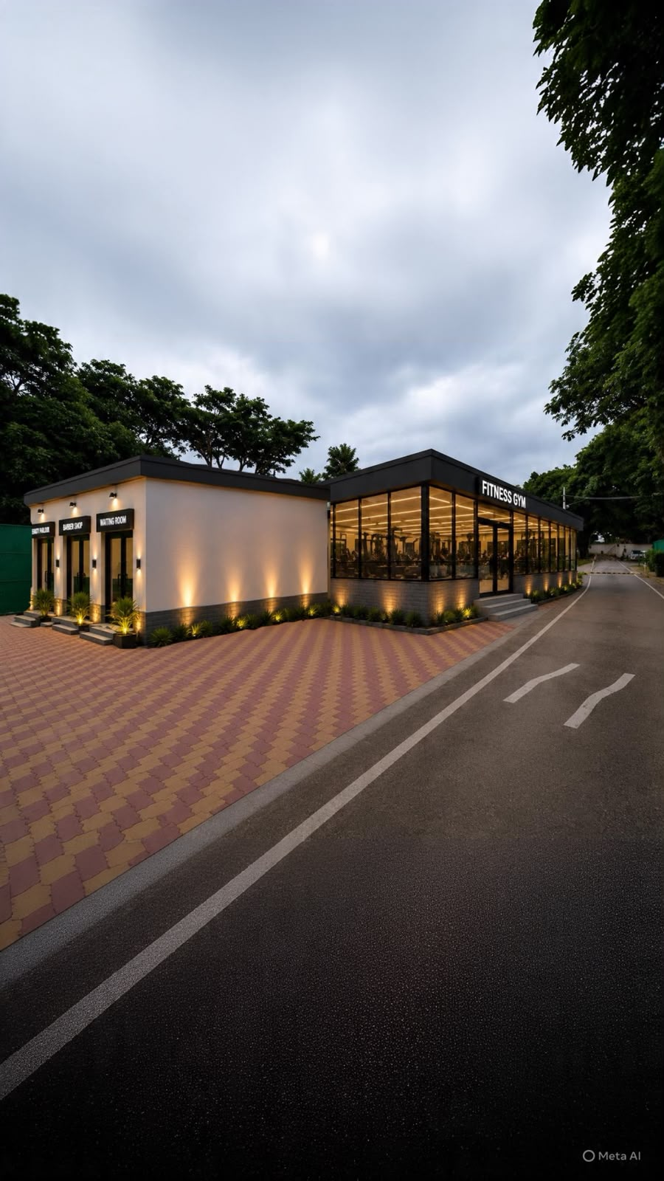
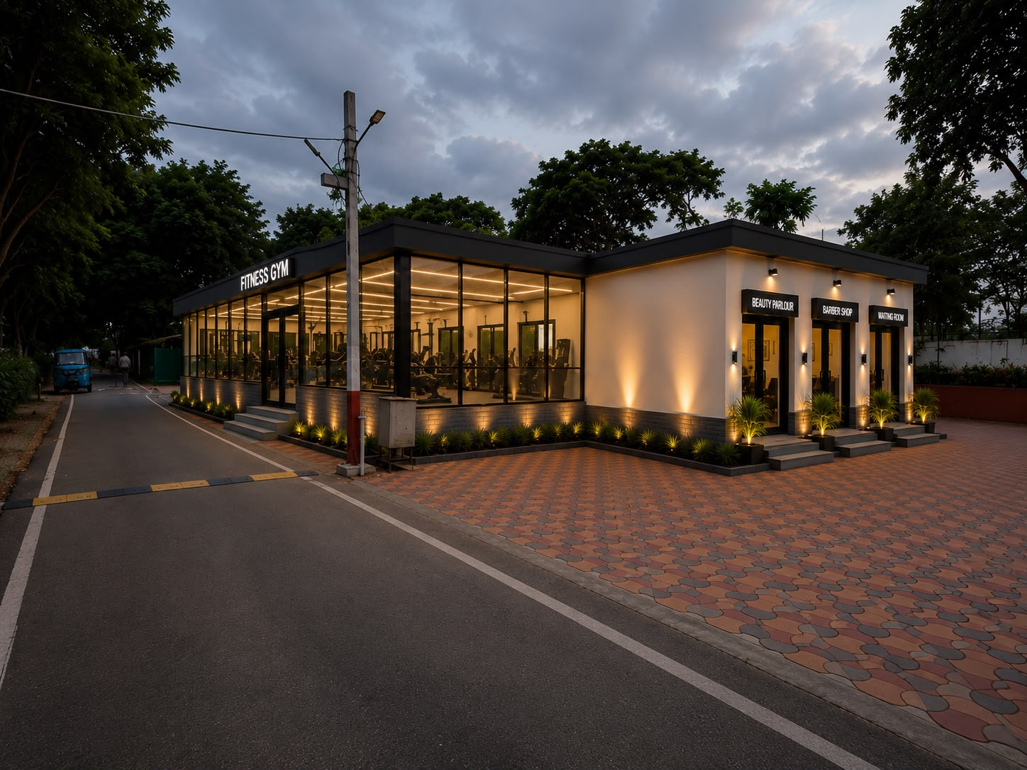
PROPOSED GYM LAYOUT
Annexure VI

